Match words and pictures
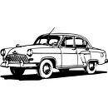
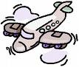
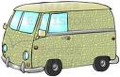
bicycle
1

2

3

bus

car
1

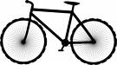
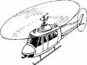
4

5

6

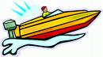
helicopter

hot-air balloon

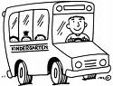
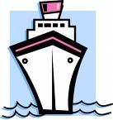
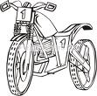
jet ski
7

8

9

motorbike

motor boat

motor scooter

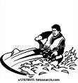
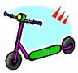
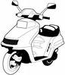
ship
scooter
submarine
train
van
plane
10

11

12

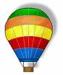
13

14

15

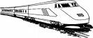
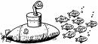

Write the words

- The quickest : ……………………………………………………………………………………
- The fastest : ……………………………………………………………………………………
- The slowest : ……………………………………………………………………………………
- The most comfortable : ……………………………………………………………………………………
- What you have tried : ……………………………………………………………………………………

