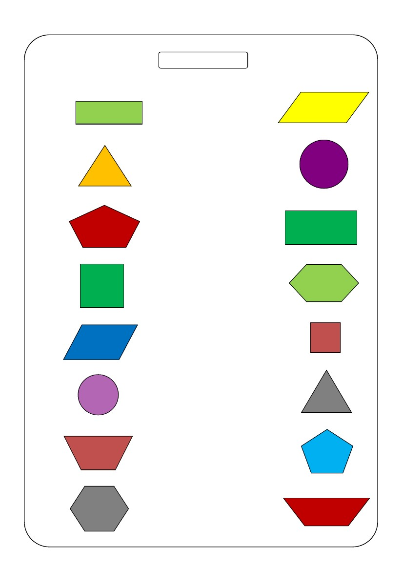
Име: ___________________________________
Бодови: _________________
Поврзи!
Поврзи ги истите форми:
Printable Math Worksheets @ www.mathworksheets4kids.com
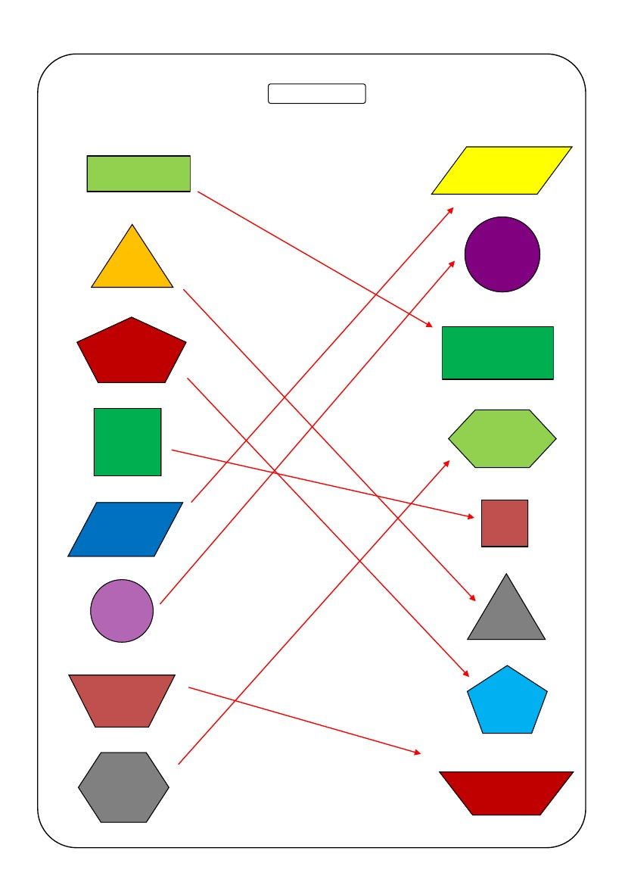
Name: ___________________________________
Score: _________________
Answer key
Match the similar shapes:
Printable Math Worksheets @ www.mathworksheets4kids.com

