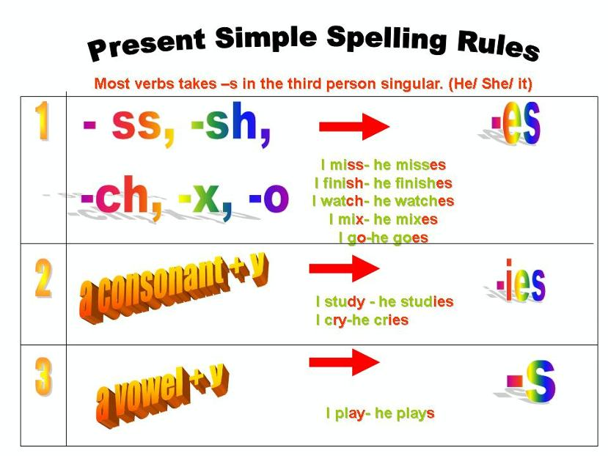
PRESENT SIMPLE SPELLING RULES

Some verbs have present simple spelling changes with ‘he’, ‘she’ and ‘it’.

I Write the he/ she/ it form of the verbs in the box in the correct columns.
carry enjoy hurry wash watch say fly destroy marry pay go do stay relax try
y -ies
____________________________________________________________
+ -es
____________________________________________________
+ -s
_____________________________________________________




1 Sarah studys/studies German at school. 11 The plane flies/flys low over the sea.
2 Mary visites/visits us twice a week. 12 Kate washess/washes her hair every day.
3 I hope my elder brother passes /pasies the exam. 13 My mother bakes/ bakess cakes every Sunday.
4 Dad always teaches/teacheis me new things. 14 John lives/livs in the city most of the year.
5 I don’t/doesn’t live in the city. 15 He goes/gos to school at eight o’clock.
6 Sam often plaies/plays tennis. 16 The Sun doesn’t/dosn’t go round the Earth.
7 Jeremy carries/carrys my bag. 17 Peter watchies/watches TV every evening.
8 Ned takes/takies care of his mother. 18 Nick never crys/cries.
9 Mark always does/dos his homework. 19 He buies/buys a cup of coffee every morning.
10 Anna enjoyes/enjoys going swimming. 20 My sisters study/studies hard at school.

III Write the verbs in the present simple.
Mrs. Green 1___________ (hurry) to work every morning. She 2____________ (teach) Literature at the college in Bath. Mr. Green often 3_________ (go) with her and 4_____________ (carry) her bag. She always has a big bag full of books and her husband 5____________ (worry) about her back.
From time to time Mrs. Green 6__________ (go) to London for a few days for her work. Her mother
7__________ (stay) with her daughter’s family, as the Greens have three children. Their grandmother
8___________ (make) their food, 9 ___________ (wash) their clothes and 10 _________ (tidy) the house. She also 11 __________ (play) with her grandchildren or 12 _________ (watch) TV with them.
Mrs. Green isn’t happy in London. She 13 ___________ (enjoy) her work but she 14 ____________ (say) she 15_____________ (miss) her family a lot.

II Underline the correct verbs in the sentences.

