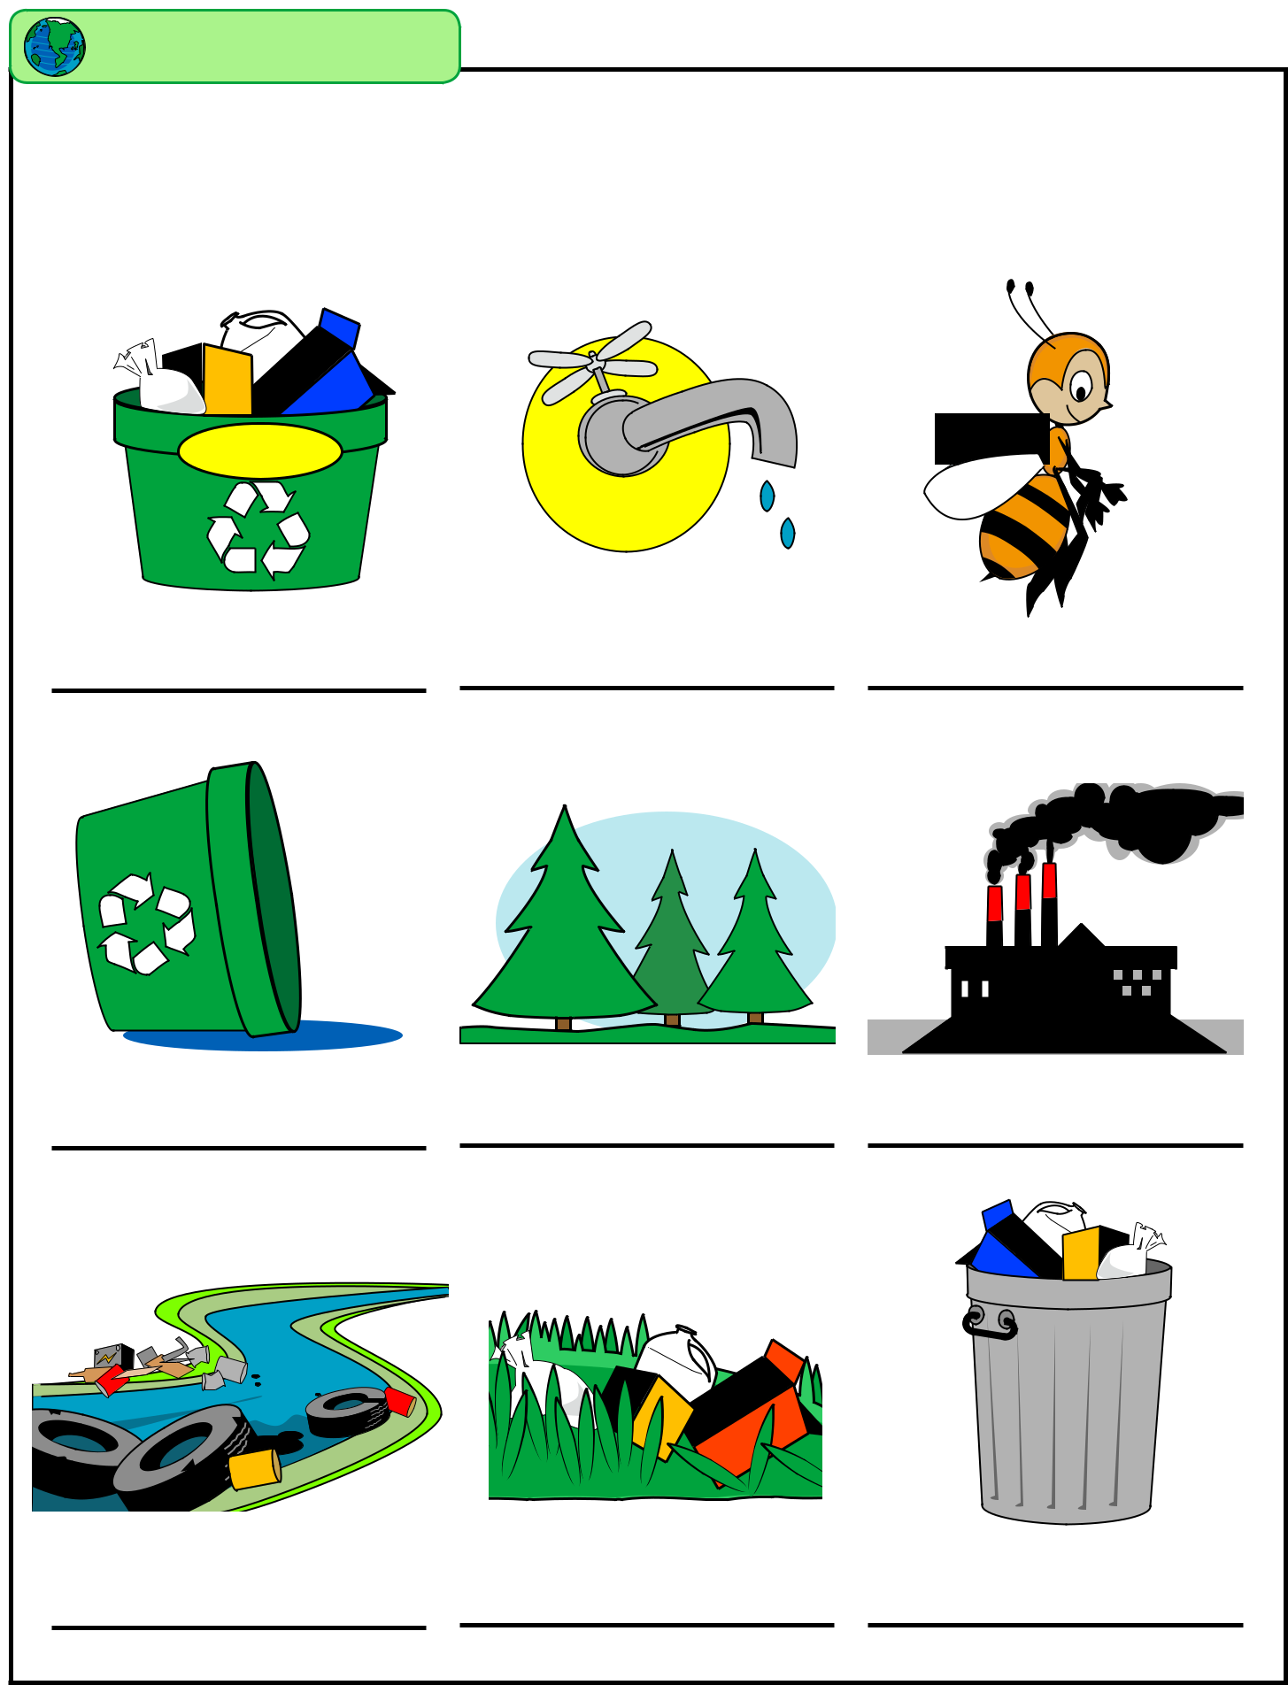  Earth Day | Name: __________________________________

Are These Things Good or Bad?

Which of these things are bad for the environment, and which are good?

Recycle

Drip
Drip

Drip

TRASH

Copyright © 2015 K12reader.com. All Rights Reserved. Free for educational use at home or in classrooms.

